Poll Your Way

Josh Lohman

Karl Ehlhardt

Jason Davis

Table of Contents

Mission Statement 3

Database 4

Table 1 - poll_Questions 4

Table 2 - poll_Choices 4

Table 3 - user_Responses 4

Features 5

Trello Link 5

Schedule 6

# Mission Statement

The purpose of this project is to encourage feedback from team members. The application should enable co-workers to give feedback on a variety of topics. With increasing communication from electronic media dev-ops could showcase their talents with this application as their fellow workers ask for an interactive and user friendly platform to deliver feedback about leadership decisions and lifestyle changes.

# Database

The database will consist of a three tables to store the polls.

## Table 1 - Poll

Integer PollId (Primary key)

Integer OwnerId

String PollQuestion

Integer PublishFlag

Integer Response_multiFlag

## Table 2 - Choices

Integer ChoiceId (Primary key)

Integer PollId (FK)

String Choice

Integer Count

## Table 3 - Responses

Integer ResponseId (Primary key)

Integer PollId (FK)

Integer OwnerId (FK)

String Selection

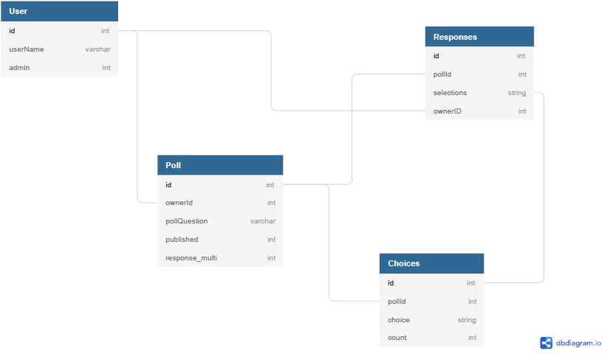

# Features

Features of this application include account permissions, adding and editing polls, poll response options and totals. The two account permission levels include users and administrators. Administrators can view and control polls while users can view and respond. The response to a question is selectable by the administrator as either single or multiple answers. The users can view result totals after submitting their poll.

|  |  |
| --- | --- |
| Version 1.0 / MVP | Version 2.0 / Stretch Goals |
| * Create admin account * Grant admin permission to create, read, update and delete single response poll * Grant admin permission to create, read, update and delete multi response poll * Flag draft or publish mode * Search/view questions * Search/view results | * More admin permissions like color, email notification * Email authentication * Timed responses |

# Trello Link

<https://trello.com/b/zAqQvmgV/polling-app>

# Schedule

This project is the equivalent of three sprint cycles in agile methodology. This section includes a time span of the next few weeks. The schedule includes deployment, time set aside to tackle especially challenging features, testing, etc. Consider whether your team will be working over the weekend(s). The table is a guideline and does not represent each day’s work/logic.

|  |  |  |  |  |
| --- | --- | --- | --- | --- |
| **Monday** | **Tuesday** | **Wednesday** | **Thursday** | **Friday** |
| Project Plan Kick-off Meeting | Sprint 1 Plan Meet-up  Create Project | Daily standup  Scaffold   * Data * Model * Service | Daily standup  Scaffold   * Data * Model * Service | Daily standup  Scaffold   * Data * Model * Service |
| **9 Monday** | **Tuesday** | **Wednesday** | **Thursday** | **Friday** |
| Sprint 1 Review and Retro Meet-up  Sprint 2 Plan Meet-up | Daily standup   * Model Admin * Model User | Daily standup  Single response   * Service Admin * Service User | Sprint 2 Review and Retro Meet-up  Multi response   * Service Admin * Service User | Daily standup  Services test |
| **Monday** | **Tuesday** | **Wednesday** | **Thursday** | **Friday** |
| Sprint 3 Plan Meet-up | Daily standup   * Controller Admin * Controller User | Daily standup   * Controller Admin * Controller User | Sprint 3 Review and Retro Meet-up   * Search Question * Search Response | Daily standup  Controller & search test |
| **Monday** | **Tuesday** | **Wednesday** | **26 Thursday** | **Friday** |
| Sprint Final Meet-up | Daily standup  Final Test | Daily standup  Showcase Prep | Final Showcase |  |